PROGRAMMING IN JAVA

Assignment – 2:

1. import java.lang.\*;

import java.util.\*;

class day2p1 {

     public static void main(String args[]) {

           String s1 = "sachin";

        String s2 = "sachin";

        String s3 = "vishnu";

        String s4 = "M.Vishnu";

        System.out.println("Comparing the strings: " + s1.equals(s2));

        System.out.println("comparing the strings:" + s3.equalsIgnoreCase(s1));

        System.out.println("comparing the strings:" + Objects.equals(s2,s3));

        System.out.println("comparing the strings: " + s1.compareTo(s3));

     }

}

Output:

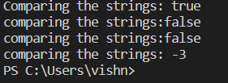

2. import java.util.\*;

class day2p2 {

    public static void main(String args[]) {

          String s1 = "welcome to NPTEL";

          System.out.println(s1.endsWith("NPTEL"));

          if(s1.endsWith("NPTEL"))

          System.out.println("String ends with NPTEL");

          else

          System.out.println("String doesnt end with NPTEL");

    }

}

Output:

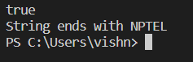

3. import java.text.\*;

import java.util.\*;

class day2p3 {

    public static void main(String args[]) {

         SimpleDateFormat f= new SimpleDateFormat("dd/MM/yyyy hh:mm:ss");

         Date d = new Date();

         System.out.println(f.format(d));

    }

}

Output:

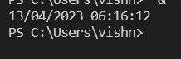

4. class day2p4 {

    public static void main(String args[]) {

        String s1 = "welcome to NPTEL";

        int s2 = s1.indexOf("N");

        int s3 = s1.indexOf("l");

        System.out.println(s2 + " " + s3);

    }

}

Output:

11 2

5. import java.util.\*;

class day2p5 {

    public static void main(String args[]) {

        String s1 = "welcome to NPTEL";

        String s2 = s1.replace("wel","del");

        System.out.println(s2);

    }

}

Output:delcome to NPTEL

6. class day2p6 {

    public static void main(String args[]) {

        String s1 = "welcome to NPTEL";

        System.out.println("the original string:" + s1);

      System.out.println("substring:" + s1.substring(0,6));

    }

}

Output:

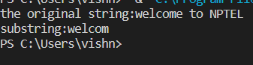

7. class day2p7 {

    public static void main(String args[]) {

        String s1 = " welcome to NPTEL";

        System.out.println(s1);

        System.out.println("string after trimming:"+s1.trim());

    }

}

Output:

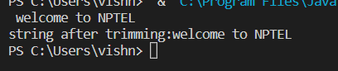

8. class day2p8 {

    public static void main(String args[]) {

        String s1 = "welcome to NPTEL";

        System.out.println("original string:" + s1);

        String s2 = s1.toLowerCase();

        System.out.println("lowercase string:" + s2);

        String s3 = s1.toUpperCase();

        System.out.println("UPPERCASE string:" + s3);

        int a = s1.length();

        System.out.println("Length of the string:"+a);

    }

}

Output:

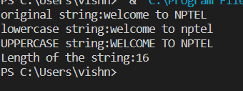

9. class day2p9 {

    public static void main(String args[]) {

        String s1 = "welcome to NPTEL";

        String s2 = "welocme to Saveetha";

        String s3 = "welocme to india";

     boolean   s4 = s1.equals(s2);

    boolean  s5 = s2.equals(s3);

        System.out.println(s1 + " equals "+ s2 +" :"+ s4);

        System.out.println(s2 + " equals "+ s3 + " :"+s5);

    }

}

Output:

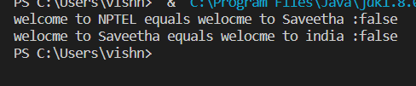

10. import java.util.\*;

class Account {

    int bal;

    Scanner s = new Scanner(System.in);

    Account() {

        bal = 50;

    }

    public void add(int n)

    {

        //System.out.println("enter money to add into account:");

        // int n = s.nextInt();

         bal = bal + n;

        System.out.println("current balance:" + bal);

    }

    public void withdraw(int m){

       // System.out.println("enter withdrawal amount:");

       // int m = s.nextInt();

        if(m>bal)

        {

            double charge = bal \* 0.05;

            System.out.println("charges:"+charge);

        }

        bal =bal - m;

        System.out.println("remaining balance is:"+bal);

    }

  //  public void balanace() {

   //     System.out.println("current balance:"+bal);

   // }

}

class day2p10 {

    public static void main(String args[]) {

        Account a = new Account();

        a.add(100);

        a.withdraw(30);

       // a.balance();

    }

}

Output:

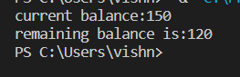

11. import java.io.\*;

import java.util.\*;

 class day2p12 {

    public static void main(String args[]) {

        try {

            Scanner sc = new Scanner(System.in);

            int count = 0, n = 100, i, j = 0, m = 4;

            int[] a = new int[10];

            System.out.println("Enter the number:");

            n = sc.nextInt();

            if (n <= 0) {

                System.out.println("Enter valid number");

            } else {

                for (i = 1; i <= n; i++) {

                    if (n % i == 0) {

                        a[j] = i;

                        System.out.println("..." + i);

                        count++;

                        j++;

                    }

                }

                System.out.println("The number of factors:" + count);

            }

            System.out.println(m + "th item " + a[m - 1]);

        } catch (Exception e) {

            System.out.println("Enter only numbers");

 }

}

}

Output:

